6A^{th} Grade: Unit 14, Lesson 3

- What is the value of the Algebra Tiles shown?
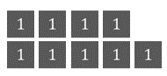
9

- What is the value of the Algebra Tiles shown?
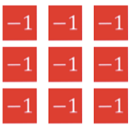

-9

- What is the value of x in this equation?
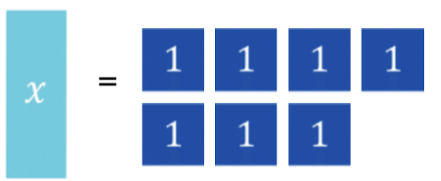

7
- What is the equation represented on the number line?
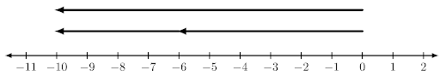

-6+(-4)= -10

- What is the value of y?
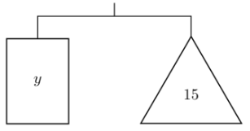

15

- What is the value of the expression 19 + (-19)?

0

